Present view
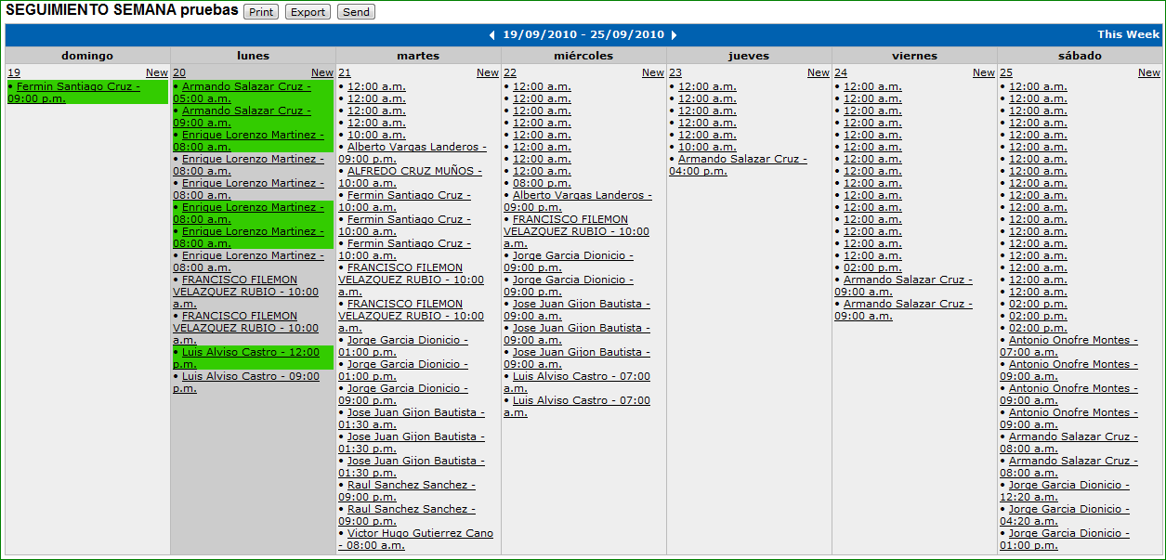

Desired view
sample fields
 | Sunday | Monday | Tuesday | Wednesday | Thursday | Friday | Saturday
 | Day - new | Day - new | Day - new | Day - new | Day - new | Day - new | Day - new
Column a - value 1 | Register | Register |  | Register | Register
 | Register |  |  | Register
 | Register
 |  | Register
Column a - value 2 | Register |  | Register | Register
 | Register |  |  | Register
 | Register |  |  | Register
sample values
 | Sunday | Monday | Tuesday | Wednesday | Thursday | Friday | Saturday
 | 12 - new | 13 - new | 14 - new | 15 - new | 16 - new | 17 - new | 18 - new
Peter | 09:00 - visit | 08:00 - visit |  | 10:00 visit | 07:00 - visit
 | 11:00 - visit |  |  | 21:00 - visit
 | 14:00 - visit
 |  | Vacation
Roger | 09:00 - visit |  | 08:00 - visit | 13:00 - visit
 | 11:00 - visit |  |  | 21:00 - visit
 | 14:00 - visit |  |  | Training

